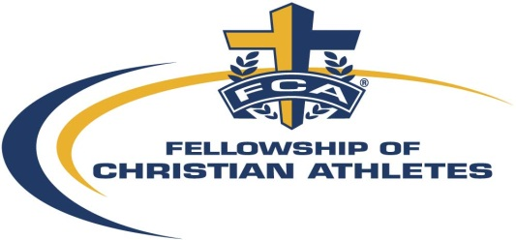

Alexandria Fellowship of Christian Athletes FCA)

Bubble Ball Rental Agreement

The renter (as defined as the individual, organization, or company who rents or is associated with renting Alexandria FCA Bubble balls) agrees to the following policies and terms.

1. The renter agrees to indemnify, defend, and hold harmless Alexandria FCA from any or all claims and judgments for damages and expenses to which Alexandria FCA, may be subjected to or which they may suffer or incur by reason of any action by renter or its guests, agents, servants or employees during its use of the equipment.
2. The cost of any damage to Alexandria FCA equipment requiring repairs or additional cleaning care, beyond normal wear and tear, caused by the renter's or its guests' misuse or unsupervised use of the equipment shall be paid by the renter. This includes the theft or damage of equipment and supplies, and soiling of the equipment such as vomit, blood, colored or sugary drinks and liquids, or excessive mud.
3. The use of tobacco and alcohol products is prohibited during the rental.
4. All players must sign a waiver/release before playing. Minors must have their parents/guardians sign for them.
5. For safety reasons, Alexandria FCA may deny access to players who cannot safely fit into the equipment.
6. The renter asserts that it has the approval from the venue where the rental will take place to have Bubble balls.
7. Cancellations and Refunds:
a. If the renter cancels the rental at any time, all payments will be refunded.
b. To postpone or reschedule the rental, the renter should give at least one-week’s notice.
c. Alexandria FCA reserves the right to cancel the rental based on the lack of compliance with any of the criteria stated herein or due to weather concerns. If Alexandria FCA cancels a rental due to weather, before the rental takes place, the renter may select a makeup date, based on Alexandria FCA availability. If the renter does not wish to makeup up the date, Alexandria FCA will refund the payment, excluding the deposit and processing fee. This refund is not applicable once a rental begins.
9. Payment: Cost for renting the bubble balls is $300 per event. A refundable deposit of $300 is due upon booking the rental, which will be returned providing there is no damage to the balls.

LIABILITY DISCLAIMER

1. This rental equipment has been received in good condition and will be returned in the same
condition (ordinary wear and tear accepted)
2. Customer assumes all responsibility for injuries to persons or damages to property, and agrees
to release and hold Alexandria FCA harmless for any and all claims, of whatsoever nature, arising out of use of the rental equipment while in his/her custody. In the event that the release and hold harmless as contained herein is held unenforceable for any reason, Customer herby agrees to a limit on any damages claimed by Customer to the total paid to Alexandria FCA for the rental.
3. Customer agrees to company right to enter premises of customer at anytime to repossess said
equipment.
4. Customer agrees to reimburse Alexandria FCA for all attorney fees, an amount not
less than 50% of all sums due, court cost and expenses incurred by Alexandria FCA to enforce collection or to preserve or enforce rights under this contract.
5. Customer agrees not to loan, sublet or otherwise depose of equipment or use it at any other
location.
6. Customer agrees to pay in full the replacement cost, including labor, for all damages to rental
equipment.
7. If the inflatable equipment is lost, stolen, or damaged beyond repair the renter agrees to pay
The replacement cost.
8. Customer agrees to ensure that all users (and users’ guardians) of the rental equipment sign
liability waivers.
9. THERE ARE NO WARRANTIES OF MERCHANTABILITY OR FITNESS EITHER EXPRESSED OR
IMPLIED.
The person(s) or organization renting this Equipment from Alexandria FCA will be held
responsible and liable for any and all damage or injury occurring for any reason whatsoever. I have read the above agreement and fully understand and accept the conditions as above. I am aware that while in my care I am fully responsible for the bubble balls and will pay for any loss or damages that may occur.

NAME___________________________________ SIGNATURE________________________________________

DATE______________________

